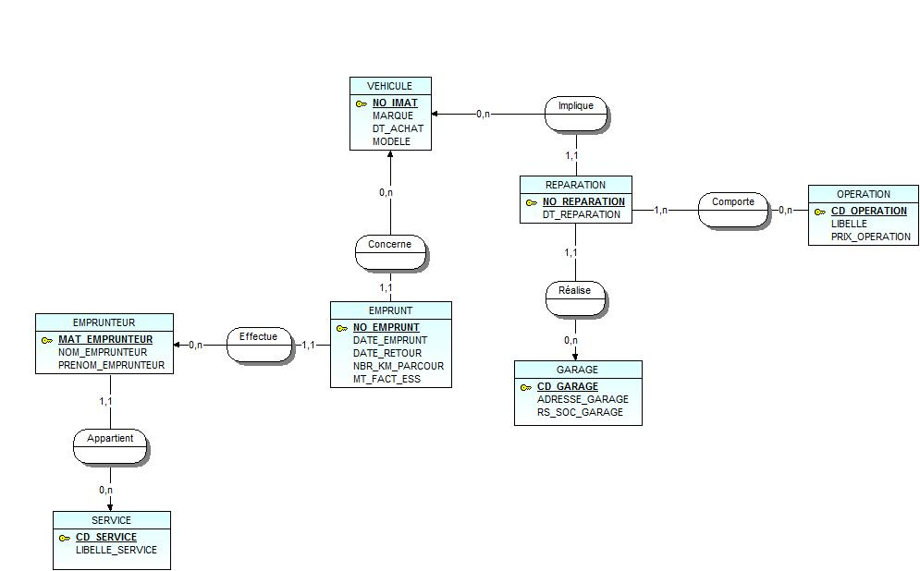**TP VEHICULE**

1. **MCD**